Managing risks of storing chemicals in the workplace
Guidance material

Disclaimer
Safe Work Australia is an Australian Government statutory agency established in 2009. Safe Work Australia includes Members from the Commonwealth, and each state and territory, Members representing the interests of workers and Members representing the interests of employers.
Safe Work Australia works with the Commonwealth, state and territory governments to improve work health and safety and workers’ compensation arrangements. Safe Work Australia is a national policy body, not a regulator of work health and safety. The Commonwealth, states and territories have responsibility for regulating and enforcing work health and safety laws in their jurisdiction.

ISBN 978-1-76051-605-5 (PDF)
ISBN 978-1-76051-606-2 (DOCX)

Creative Commons
This copyright work is licensed under a Creative Commons Attribution-Noncommercial 4.0 International licence. To view a copy of this licence, visit creativecommons.org/licenses In essence, you are free to copy, communicate and adapt the work for non-commercial purposes, as long as you attribute the work to Safe Work Australia and abide by the other licence terms.

Contact information
Safe Work Australia | info@swa.gov.au | www.swa.gov.au

Contents

1. Introduction 4
1.1 What are hazardous chemicals? 4
1.2 Why is it important to safely store hazardous chemicals? 4
1.3 What is involved in managing risks? 5
2. Identifying hazards 6
2.1 Identify your hazardous chemicals 6
2.2 Identify chemicals that are incompatible 6
3. Assessing Risks 8
4. Controlling Risks 8
4.1 The hierarchy of control measures 8
4.2 Choosing a location to store your chemicals 10
4.3 Separating incompatible chemicals 11
5. Reviewing Control Measures 13
6. Storage Checklist 14
7. Segregation Chart 16
8. An Example of Managing Chemical Storage Risks 17

Introduction
The guide is intended for small and medium businesses who do not have major chemical stores and who do not have expertise in managing the risks of chemical storage. It provides information on how to manage health and safety risks associated with storing hazardous chemicals in the workplace.
For further information on managing the risks of using, handling and storing hazardous chemicals in the workplace, including your work health and safety duties, please refer to the model Code of Practice: Managing risks of hazardous chemicals in the workplace.

What are hazardous chemicals?
Hazardous chemicals are substances, mixtures and articles that can pose a health or physical hazard to humans. They may be solids, liquids or gases.
Health hazards are properties of a chemical that cause adverse health effects. Examples of chemicals with health hazards include toxic chemicals, carcinogens and chemicals which may cause infertility or birth defects. Exposure to these chemicals usually occurs through inhalation, ingestion or skin contact.
Physical hazards are properties of a chemical that can result in immediate injury to people or damage to property. Examples of chemicals with physical hazards include flammable liquids, compressed gases and self-heating substances. Corrosive chemicals often have both physical and health hazards, as they may damage skin and eyes as well as other materials.

Why is it important to safely store hazardous chemicals?
Even when not in use, chemicals can still pose a risk. Flammable and oxidising chemicals may cause or contribute to a fire, corrosive chemicals can injure people and damage property and structures they come into contact with and toxic chemicals can poison people who are exposed to them. Compressed gases can also suffocate or poison workers if they leak.
Additionally, some chemicals are not compatible with one another. When incompatible chemicals mix they may:
- ignite or explode
- release toxic, flammable or corrosive gases, or
- corrode chemical containers, causing them to leak.
It’s important that you identify which chemicals are incompatible and ensure that hazardous chemicals are stored safely in a way that:
- minimises the chance of any incidents and reactions, and
- reduces the chance that stored chemicals will contribute to or worsen an incident.
Information about identifying incompatible chemicals can be found in section 2.2.
Figure 1 Stored chemicals may create hazardous fumes
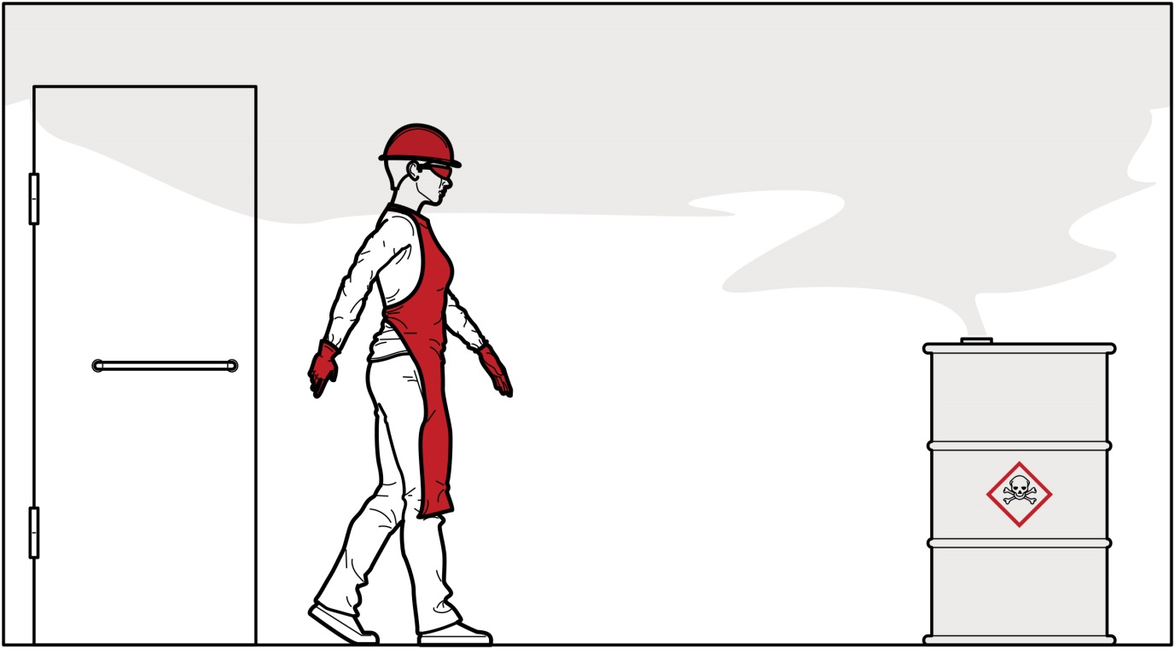
Damaged or uncapped containers can create vapour clouds as shown in Figure 1. These vapours are often invisible and may accumulate indoors, especially if the storage area does not have adequate ventilation.

What is involved in managing risks?
You should manage the risks associated with storing hazardous chemicals by following a systematic process to:
- Identify hazards – find out what could cause harm.
- Assess risks, if necessary – understand the nature of the harm that could be caused by the hazard, how serious the harm could be and the likelihood of it happening. This step may not be necessary if you are dealing with a known risk with known controls.
- Eliminate risks so far as is reasonably practicable.
- Control risks – if it is not practical to eliminate the risk, implement control measures in accordance with the hierarchy of control measures (as described in section 4.1).
- Review and maintain control measures to ensure they are working as planned.
Further guidance on the risk management process is in the model Code of Practice: Managing risks of hazardous chemicals in the workplace.

Identifying hazards

Identify your hazardous chemicals
The first step in managing risks associated with hazardous chemicals is to identify which hazardous chemicals are stored at the workplace. A list of hazardous chemicals used at your workplace and their current safety data sheets (SDS) must be available in your workplace’s hazardous chemical register. SDS can also be obtained from the manufacturer, importer or supplier of the hazardous chemical.
The most reliable way to find information about a chemical is to check the chemical’s SDS. All SDS have a consistent format and include information about storing the chemical. SDS are broken into 16 sections, each of which covers a different topic. It is important to consider the entire SDS when planning and managing the storage of hazardous chemicals; however the most important sections for storing hazardous chemicals are:
- Section 2: Hazard Identification – This section contains information about all of the chemical’s hazards. For example if the chemical is flammable, toxic or can cause cancer it will be listed here.
- Section 7: Handling and Storage – This section contains information about safe storage of the chemical and other kinds of chemicals it should not be stored with.
- Section 10: Stability and Reactivity – This section contains information about how to keep the chemical stable and which other chemicals it could react with.
Useful information can be found in other sections of the SDS. For example, section 5 (fire-fighting measures) contains information about the type of firefighting equipment you may need.

Identify chemicals that are incompatible
It is not always obvious which chemicals are incompatible. Some types of chemicals are always incompatible (for example oxidisers and flammable liquids) but some chemicals with similar hazards are also incompatible (for example, acids and bases).
To find out which chemicals are incompatible you should refer to their SDS. SDS provide information about chemical incompatibility in sections 7 (Handling and Storage) and 10 (Stability and Reactivity) Section 7 of this guide contains a segregation chart which identifies the types of chemicals that can be stored together and those that cannot.
When identifying chemical incompatibility you should also consider:
- combustible materials such as wood or paper, which may increase the likelihood or severity of a fire
- non-hazardous chemicals that may react with hazardous chemicals
- the materials that containers are made out of, as some hazardous chemicals are not compatible with the materials other chemicals containers are stored in, for example aluminium containers may react with strong alkaline solutions
- potential ignition sources, including work areas that may be used for hot work such as welding or grinding, and
- firefighting equipment, as the equipment suitable for one hazardous chemical may not be suitable for all chemicals you store.
Figure 2 Incompatible chemicals may react to cause fire
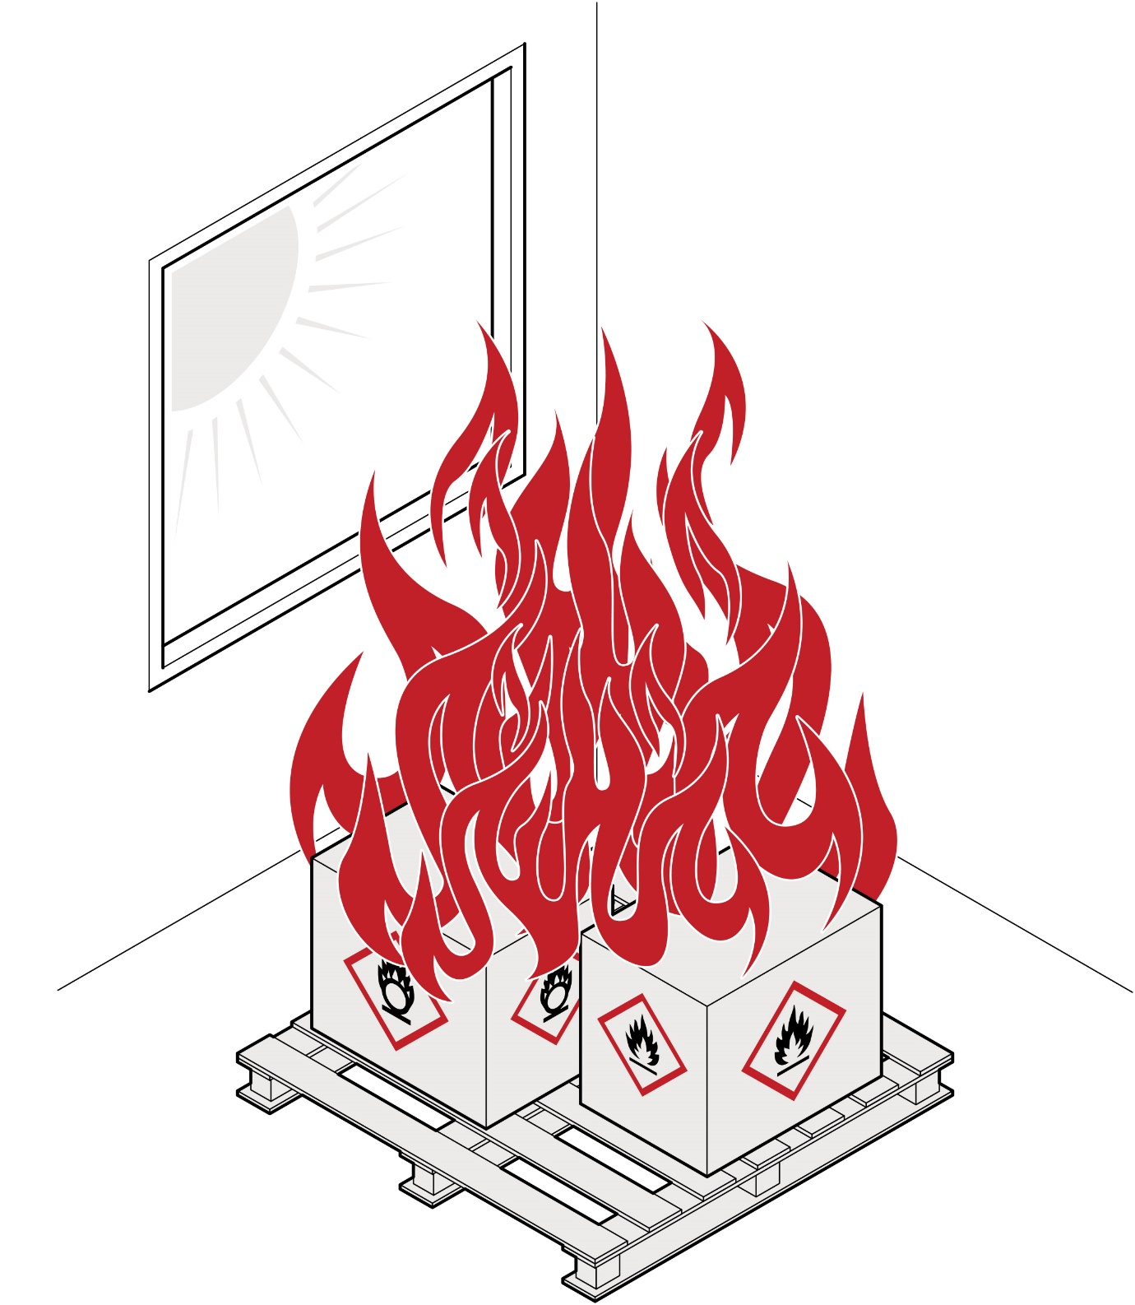
Figure 2 shows cartons of flammable and oxidising chemicals stored together in direct sunlight. The mixture of flammable and oxidising chemicals make it very easy for a fire to start, and could result in an intense fire.
Flammable and oxidising chemicals are incompatible and should be separated. They should also be stored away from ignition sources including direct sunlight.

Assessing Risks
Once you have identified the hazards, you should assess the risks (that is, the likelihood of harm and how serious the harm could be).
A risk assessment can help you work out what action should be taken to control the risks associated with chemicals that are stored at your workplace, and how urgently the action needs to be taken.
When assessing risks you should consider the quantity of chemicals you store, the severity of their hazards and the likelihood of an incident.
When assessing the severity of a chemical’s hazards you should refer to its SDS. The hazards listed in section 2 of the SDS are broken into different categories depending on their severity. For example, a category 1 flammable liquid will ignite more easily (at a lower temperature) than a category 2 flammable liquid.

Controlling Risks
This section contains general information about controlling the risks associated with storing hazardous chemicals. If you remain unsure about how to safely store your hazardous chemicals you should consider consulting a suitably experienced and qualified chemical safety expert.

The hierarchy of control measures
The ways of controlling risks are ranked from the highest level of protection and reliability to the lowest. This ranking is known as the hierarchy of control measures and is shown in Figure 3, along with examples of controls for chemical storage. The WHS Regulations require duty holders to work through this hierarchy when managing risks under the WHS Regulations.

Figure 3 The hierarchy of control measures
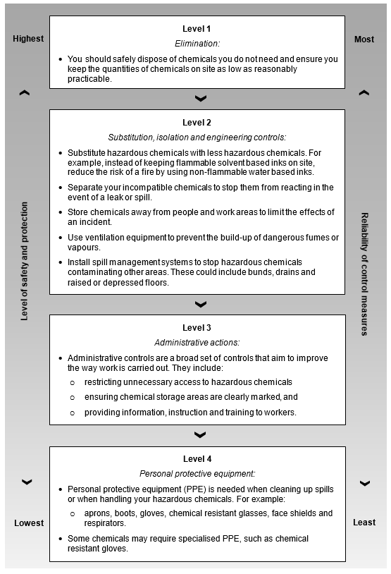

Choosing a location to store your chemicals
Before deciding where to store your chemicals you should consider the layout and attributes of your workplace. For example, the locations of:
- all buildings and services (e.g. water, gas, electricity, compressed air and steam)
- drains, pipework, vehicle routes and pedestrian access
- other work activities including hot work (e.g. welding, grinding or other work that may create an ignition source) and production areas where mixing and decanting of chemicals may occur.
These will influence the appropriate location of a storage area. Where possible, storage areas should be isolated from people and other work areas to reduce the risk and severity of any incidents. You should also consider the need for engineering controls in your storage area, such as mechanical ventilation or refrigeration.
It is often best to have more than one storage area, so that incompatible chemicals can be kept separate. If incompatible chemicals share the same storage area they should be separated within the store (known as segregation) to ensure they cannot come into contact with one another. See section 4.3 below for more information about separation techniques.
Figure 4 Floor plan of a business that stores hazardous chemicals
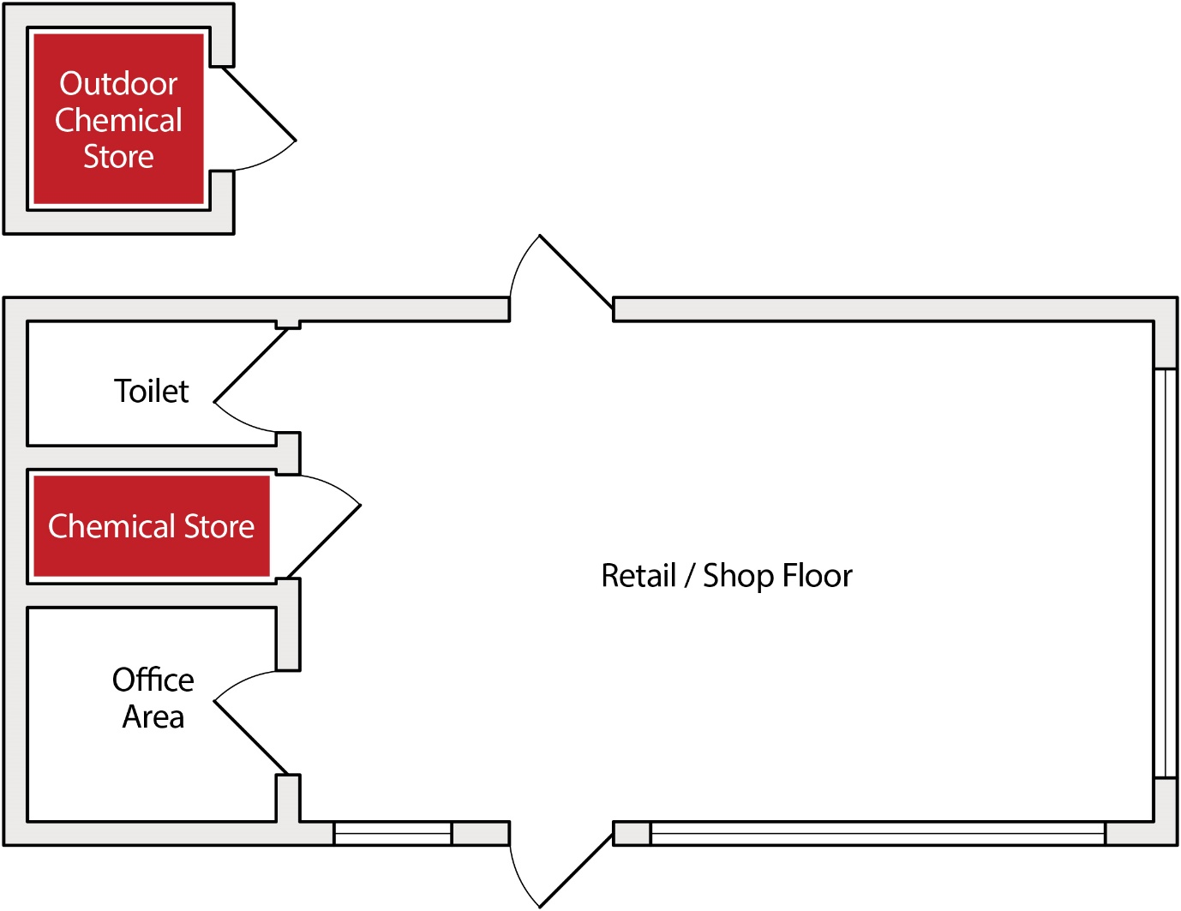
The workplace above has indoor and outdoor chemical storage areas which can be used to separate incompatible chemicals. The internal storage area is located away from exits and passage ways, ensuring escape routes are clear in the event of a fire or other incident.

Separating incompatible chemicals
Separating incompatible chemicals is one of the most important controls when storing hazardous chemicals.
Separation techniques include using:
- distance
- barriers
- separate rooms
- separate buildings, and
- external storage tanks.

The order of these separation techniques is not intended to reflect a hierarchy. When choosing separation techniques you should consider your situation to determine the most appropriate controls for you workplace.
Distance should only be used when the risk of a reaction is low. Generally, a minimum distance of 3 metres is recommended between any incompatible goods, though this may be increased or decreased depending on the level of risk. Bunding and spill trays should be in place, and distances should be measured horizontally from the edge of any spill containment system. Incompatible chemicals should never share the same bunding or drainage systems, and liquids should not be stored above solids.
Figure 5 Incompatible chemicals separated by distance
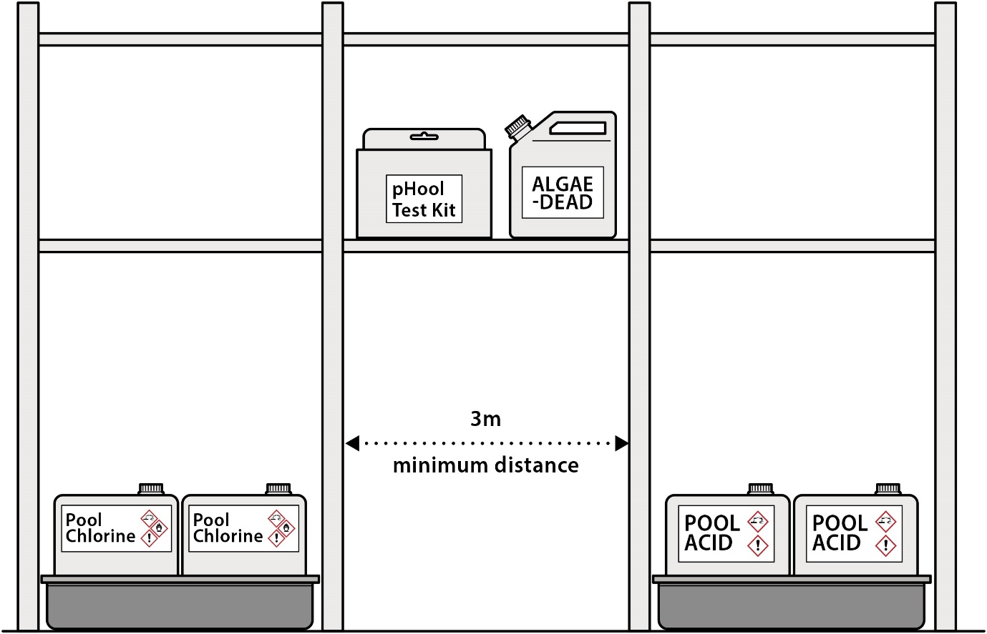
Figure 5 shows incompatible chemicals stored in the same area for customer convenience. In this case, a minimum distance of three metres separating the incompatible chemicals should be observed. Non-hazardous or non-reactive chemicals, for example test kits and biocides, can be stored within the three metre buffer.
Barriers include chemical storage cabinets, partitions between chemicals, and partitions around storage areas. Barriers should be resistant to any chemicals they are intended to contain. If using chemical storage cabinets you should make sure they meet the relevant Australian Standard for the type of chemical they store.
Separate rooms should be used when large quantities of hazardous or incompatible chemicals are stored. For example, separate fire resistant rooms should be considered for large stores of flammable or oxidising chemicals.
Separate buildings may be necessary for chemicals that cannot be safely contained within a normal work site. These are typically large quantities of extremely hazardous or reactive chemicals. Separate buildings should also be considered for chemicals that can react with water or air, or require specialised fire-fighting systems.
External storage tanks are used for storing large quantities of hazardous chemicals. One of the most common examples is petrol storage tanks for refilling vehicles at a work site. Tanks should be located outside and away from normal work areas; this allows the chemical to be separated from workers and other materials to protect them if there is an incident. Where possible, storage tanks should be protected from impact and damage, for example with bollards, barriers or fencing.
Figure 6 External storage tank
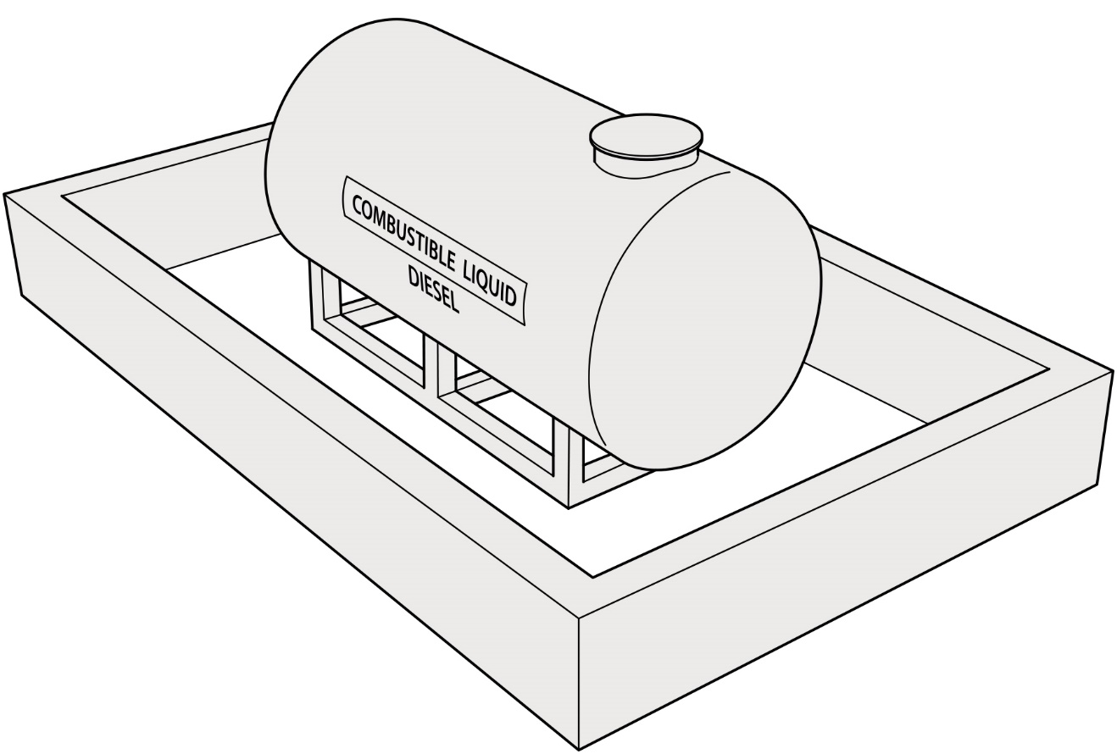
Figure 6 shows a storage tank with a solid bund to contain spills and prevent vehicles colliding with the tank. Note that bunding may not be necessary for double walled tanks, but impact protection such as bollards should be considered.

Reviewing Control Measures
You must review and maintain your control measures to ensure they remain effective.
Control measures should be reviewed to ensure they remain relevant if the chemicals you are storing change, or new information becomes available. This includes checking the control measures are fit for purpose, suitable for the nature and duration of the work and are installed and used correctly.
Maintenance of control measures may include:
- training staff regularly to ensure they know how to store and handle chemicals safely
- checking bunds, tanks, pipework and compressed gas fittings for signs of damage
- preventative maintenance and testing programs for engineering controls such as ventilation systems, fire alarms and sprinkler systems.

Storage Checklist
The following checklist sets out basic precautions that everyone who stores hazardous chemicals should take to keep their storage area safe. You can use this checklist to help you develop an inspection program for your storage area.
- Eliminate unnecessary chemicals. You should safely dispose of unwanted chemicals and chemicals that are out of date.
- Correctly dispose of empty containers. Old containers often contain residual chemical that can degrade, generate fumes or react with other chemicals added to the container.
- Ensure all chemicals are clearly labelled. Clean and reattach labels as necessary and ensure any pipe work or plant that contains hazardous chemicals is identified through a label, sign or other measure.
- Ensure your register of hazardous chemicals is up to date. Your register must include a list of the hazardous chemicals kept or used on site, as well as their current SDS.
- Ensure your storage area is clean and organised. Make sure bunds are clear or spill trays are in place and clear. You should get rid of any unnecessary items in the storage area, like combustible materials (wood, rags etc.) that could be fuel for a fire.
- Ensure incompatible chemicals are separated. You should also make sure incompatible chemicals do not share bunding or drainage systems. You can use signs to make it clear where chemicals should be stored. Liquids should not be stored above solids.
- Inspect storage tanks and containers. Ensure that containers are sealed when not in use and that they are put away correctly. If any containers are leaking or show signs of corrosion make sure you repackage or dispose of the chemicals.
- Remove any food or personal belongings from the chemical storage area. If food or personal belongings are contaminated they could make someone ill.
- Remove or manage other sources of risk. Where possible remove ignition sources and machinery that could damage containers. Where necessary protect chemicals from sunlight.
- Check storage systems. Some chemicals should be stored locked up or refrigerated; others need constant ventilation to ensure hazardous fumes do not build up. Ensure these systems are in place and operating correctly.
- Check fire-fighting equipment. Make sure your firefighting equipment has been tested recently and is suitable for your chemicals. Where relevant, you should also ensure workers are trained in the use of the fire-fighting equipment.
- Check spills kits. Ensure there is a suitable way to clean up any chemicals that spill. This includes making sure that workers know what to do if there is a spill or leak.

Figure 7 Chemical stores should be inspected regularly to prevent spills and other incidents
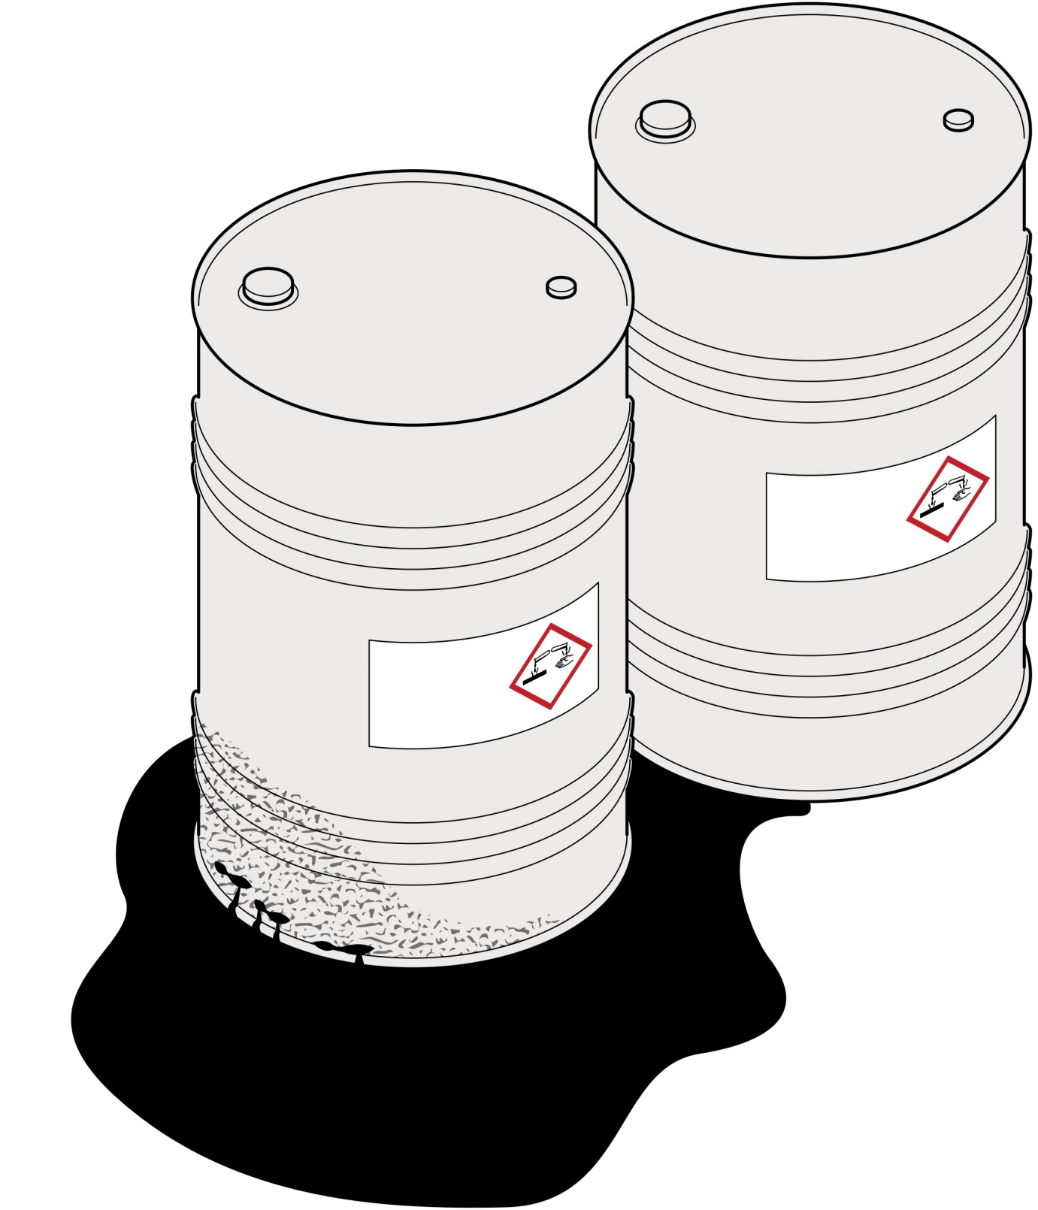
In Figure 7 corrosive liquid has leaked from a damaged drum and is pooling on the floor and touching a neighbouring drum. Steel drums used to contain corrosive liquids often include internal corrosion protection, for example Teflon lining, which does not protect them from external sources of corrosion. As such the leak may corrode the neighbouring drum and lead to further spills, as well as being a risk to workers. Regular inspections of chemical storage areas will help prevent serious leaks and other incidents.

Segregation Chart
This segregation chart is intended to supplement the storage information found in a chemical’s SDS. It provides broad advice about which types of chemicals should be separated and the minimum separation required.
The information provided in the segregation chart is guidance only. You should also refer to the chemical’s SDS and carefully consider the types and quantities of chemicals you store when choosing appropriate risk controls.
This segregation chart is adapted from Australian/New Zealand Standard 3833:2007 The storage and handling of mixed classes of dangerous goods, in packages and intermediate bulk containers. As such, chemicals are organised by their dangerous goods classes as described in Table 1.
This segregation chart is not intended for use with gas cylinders. For gas cylinders refer to Australian Standard 4332-2004 The storage and handling of gases in cylinders.
Table 1 Description of chemicals in segregation chart
Dangerous goods class | GHS hazard class
Class 2.1 | - Flammable gases  - Flammable aerosols
Class 2.2 | - Gases under pressure
Class 3 | - Flammable liquids
Class 4.1 | - Flammable solids
Class 4.2 | - Pyrophoric solids, liquids and gases  - Self-heating substances and mixtures
Class 4.3 | - Substances and mixtures which, in contact with water, emit flammable gases
Class 5.1 | - Oxidising solids, liquids and gases
Class 5.2 | - Self-reactive substances and mixtures  - Organic peroxides
Class 6 | - All health hazards
Class 8 | - Corrosive to metals  - Skin corrosion category 1  - Serious eye damage category 1

Table 2 Recommended segregation of hazardous chemicals
Class | 2.1 | 2.2 | 3 | 4.1 | 4.2 | 4.3 | 5.1 | 5.2 | 6 | 8
2.1
2.2
3
4.1
4.2
4.3
5.1
5.2
6
8
Table 3 Recommended segregation types
Segregation key | Segregation type
 | COMPATIBLE: Chemicals with similar hazards are usually compatible. However chemicals may have more than one hazard and you should still check the SDS.
 | REFER TO SDS: Separation of these chemicals may be necessary. Consult the SDS for further guidance.
 | MINIMUM THREE METRE SEPERATION: These chemicals may react dangerously if stored together may and should be kept at least three metres apart.
 | MINIMUM FIVE METRE SEPERATION: Storing these chemicals together will significantly increase the likelihood or severity of an incident. They should be kept at least five metres apart or in separate storage areas.
 | ISOLATE: Dedicated storage areas or storage cabinets are recommended for self-reactive chemicals and organic peroxides, as is separation from other buildings and property boundaries.

An Example of Managing Chemical Storage Risks
John works at a hotel and is trying to decide how to store the chemicals kept on site. All chemicals are kept in areas not accessible to guests or the general public.
Taking stock of their chemicals, John finds they have:
- 50 litres of hydrochloric acid and 50 litres of containers of liquid chlorine for the swimming pool
- a 20 kilogram bag of garden lime
- 30 litres of assorted flammable liquids including turpentine, methylated spirits and paints, and
- four 8.5 kg LPG gas cylinders.
Referring to the segregation chart and their SDS, John discovers the following:
Hydrochloric acid: This chemical is a corrosive acid. It will react with the liquid chlorine to create toxic chlorine gas. It will also react with the garden lime and could corrode the LPG gas cylinders.
John decides to store the acid away from the other chemicals and places it in an acid proof drip tray to ensure any leaks are contained, if they occur.
Liquid chlorine: This chemical is a corrosive alkali. It is highly reactive and is incompatible with acids, metals and all flammable materials.
As with the acid, John decides to store it away from the other chemicals and places it in drip tray to ensure any leaks are contained, if they occur.
Flammable liquids: These liquids can be stored together, but they should be separated from the chlorine and acid. They should also be kept away from ignition sources, and from the gas cylinders, so that if there is a fire they do not cause the cylinders to overheat and rupture.
John notices that many of these containers are very old and are unlikely to ever be used. Rather than keeping unwanted chemicals he decides to dispose of them, and organises to have them dropped off at a local tip that accepts chemicals and paint.
He stores the remainder of the flammable liquids in a cabinet designed for the storage of flammable liquids to reduce the chance of a fire.
Gas cylinders: To prevent the gas cylinders leaking indoors, John stores them outside on their own. Knowing that the gas cylinders should be protected from heat and damage, he chooses a spot that is under cover, away from normal work areas and inaccessible to the public. This also ensures they are separated from incompatible chemicals.
He makes sure the cylinders are secured and stored in an upright position to reduce the likelihood and severity of incidents.
Garden lime: The garden lime is not classified as hazardous, but will react with acids. John decides he can either safely store it outside under cover with the gas cylinders, or indoors away from the acid.

